College Algebra Fundamentals

Section P-3 (Part 1): Graphs of Equations
Date: ________________________________
Objectives:
- Students will be able to label all parts of a coordinate grid.
- Students will be able to create scatterplots for real world data.
Main Idea | Notes
Vocabulary:  Example 1: Plotting Points on a Coordinate Grid | The Rectangular Coordinate System is also known as the  ________________________________________________________________.  Label the x- axis, y-axis, and the origin on the graph below:  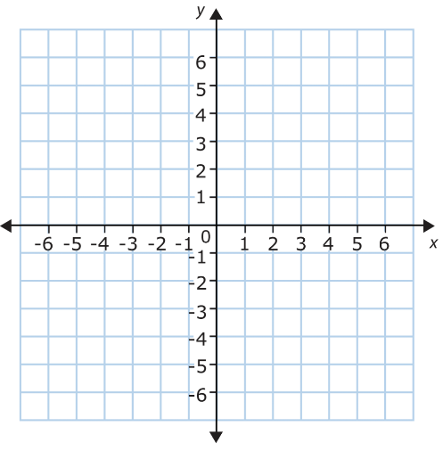  The Cartesian Plane is divided into _______________________________________________________.  Label these on the graph above.  (5, 6) is an example of an ___________________________________________________________________.  5 is the ____________________________________ and 6 is the _____________________________________.  Plot the following points on the grid below:  A(-4, 6) B(2, -3) C(-6, -4) D(7, 3)  These points all lie in different quadrants. What do you notice about their coordinates?
Example 2: Plotting Points on a Coordinate Grid | Plot the following points on the grid below:  E(5, 0) F(0, 6) G(-7, 0) H(0, -3)  These points all lie on the axes, not in quadrants. What do you notice about their coordinates?  Drawing a Scatter Plot:  Select the __________________________________________________________________________.  Represent each pair of values by ___________________________________________________________.  Then just _____________________________________________________________________________________.
Vocabulary:
Example 3: Types of Graphs | What are other types of graphs that represent data graphically?
Homework:

