College Algebra Fundamentals

Section P-3 (Part 3): Graphs of Equations
Date: ________________________________
Objectives:
- Students will be able to graph an equation using a table of values.
- Students will be able to find the x- and y-intercepts of an equation.
Main Idea | Notes
Vocabulary:  Example 1: Solution Points  Vocabulary:  Example 2: Graphing Using a Table of Values  Vocabulary | Many times, a relationship between __________________________________________ is  expressed as an equation in ____________________________________________________________.  Example:  When is an ordered pair (a, b) a solution or solution point of an equation in x and y?  Is (1, 4) is a solution of y = 7 – 3x? Why or why not?  What is the graph of an equation?  Graph y = x² - 4x using a table of values.  x y  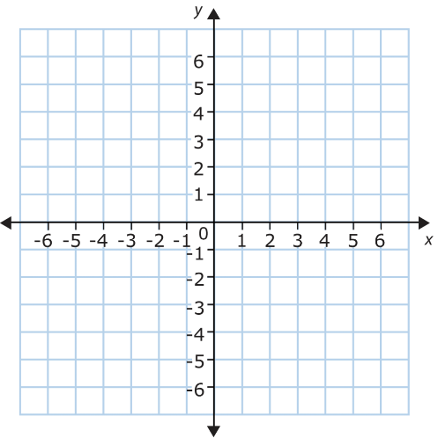  It is often easy to find solution points that have ___________________________ as either the  x-coordinate or y-coordinate.  These points are called intercepts because they are the points where the graph  _________________________________________________________________________________________________.  A graph could have ___________________ intercept, __________________________ intercepts, or  ____________________________ intercepts.
Example 3: Finding x- and y-intercepts | - Find the x- and y-intercepts of x - 2y = 12  - Find the x- and y-intercepts of y² = x + 4  - Find the x- and y-intercepts of 3x – 4y = 24
Homework:

