College Algebra Fundamentals

Section P-3 (Part 4): Graphs of Equations
Date: ________________________________
Objectives:
- Students will be able to determine whether a graph is symmetric with respect to the y-axis, x-axis, or origin.
- Students will be able to use intercepts and symmetry as sketching aids.
Main Idea | Notes
Vocabulary:  Vocabulary:  Classwork/  Homework:  Vocabulary:  Example 3: Using Intercepts and Symmetry to Sketch Graphs  Example 3 (Continued): Using Intercepts and Symmetry to Sketch Graphs  Example 4: Using Intercepts and Symmetry to Sketch Graphs  Example 4 (Continued): Using Intercepts and Symmetry to Sketch Graphs  Classwork/  Homework: | A graph is symmetric with respect to the y-axis if _________________________________________  _________________________________________________________________________________________________  Draw a graph that has y-axis symmetry.  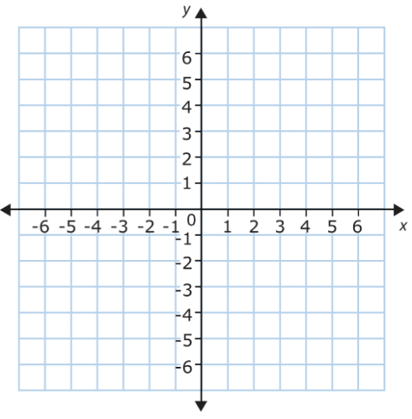  A graph is symmetric with respect to the x-axis if _________________________________________  _________________________________________________________________________________________________  Draw a graph that has x-axis symmetry.  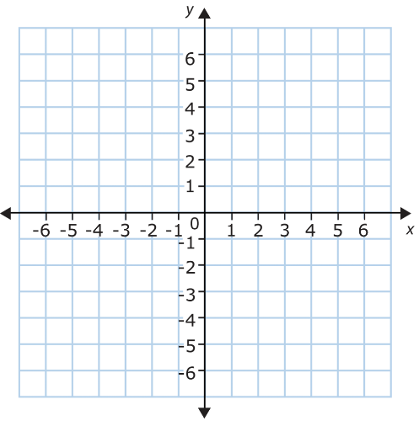  A graph is symmetric with respect to the origin if _________________________________________  _________________________________________________________________________________________________  Draw a graph that has origin symmetry.  Summary: Tests for Symmetry:  - The graph of an equation is symmetric with respect to the y-axis if  ______________________________________________________________________________________  ______________________________________________________________________________________  - The graph of an equation is symmetric with respect to the x-axis if  ______________________________________________________________________________________  ______________________________________________________________________________________  - The graph of an equation is symmetric with respect to the origin if  ______________________________________________________________________________________  ______________________________________________________________________________________  How can knowing the symmetry of a graph before attempting to sketch it be helpful?  Use intercepts and symmetry to sketch the graph of x - y² = 1.  y-intercepts:  x-intercepts:  Symmetry:  y-axis?  x-axis?  Origin?  Now, using symmetry, we can find solution points above the x-axis and then reflect them to get the graph.  x y  0  1  2  3  Use intercepts and symmetry to sketch the graph of y = |x – 1|  y-intercepts:  x-intercepts:  Symmetry:  y-axis?  x-axis?  Origin?  Now, find some additional points to help graph  x y  -2  -1  0  1  2  3  4

