College Algebra Fundamentals

Section P-4 (Part 1): Lines in the Plane and Slope
Date: ________________________________
Objectives:
- Students will be able to Graph Linear Equations in Slope-Intercept Form.
Main Idea | Notes
Vocabulary:  Example 1: Y-Intercepts | The simplest mathematical model for relating two variables is the linear equation:  ____________________________________  It is called linear because its graph is a _______________________________.  A line could be ____________________________________, __________________________________, or  _______________________________________.  Draw an example of a linear equation and a non-linear equation.  Linear Non-Linear  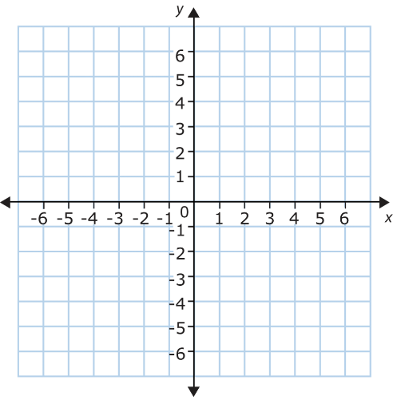  Label all the parts of slope-intercept form:  y = mx + b  Write the y-intercept for each graph below:  - b)  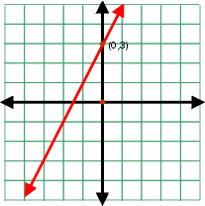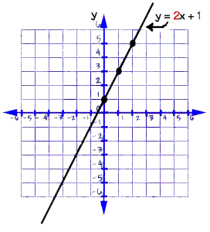  c)  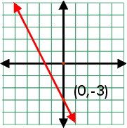
Vocabulary: | Steps to Graph an Equation Using Slope-Intercept Form:  - _________________________________________________________________________________________.  - _________________________________________________________________________________________.  - _________________________________________________________________________________________.  - _________________________________________________________________________________________.  These equations are all in Slope-Intercept Form:  - ___________________________________  - ___________________________________  - ___________________________________  Notice that these equations are all solved for y.  Graph each of the following equations.  - y = 2x + 1 b) y = -x – 4 c) y = 3/2 x – 2  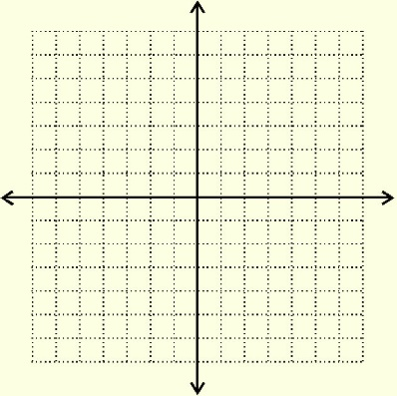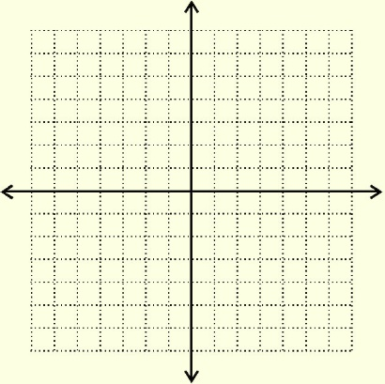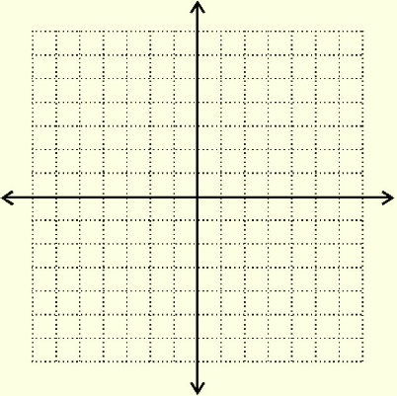
Example 2: Graphing Lines in Slope-Intercept Form

Vocabulary: | Sometimes we must solve the equation for _________________ before we can graph it.
Example 3: Graphing Lines  Vocabulary: | Graph 2x + y = 3  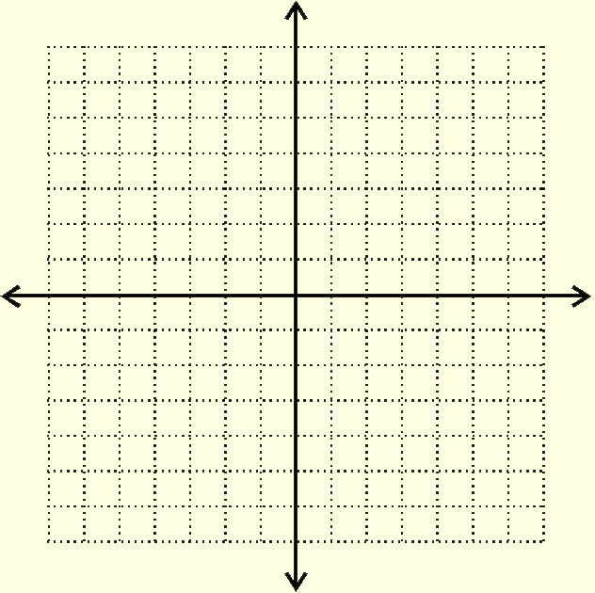  When you are asked to graph a line and there is only ONE variable in the equation,  the line will either be _________________________________ or ____________________________________.
Example 4: Graphing Horizontal and Vertical Lines | Graph each of the following equations.  a) x = 2 b) y = -2
Vocabulary: | Graphing Horizontal & Vertical Lines:  Whenever x = a, the graph is a __________________________________ line and the slope is  ______________________________________________.  Whenever y = b, the graph is a __________________________________ line and the slope is  ______________________________________________.
Homework:

