College Algebra Fundamentals

Section P-4 (Part 2): Lines in the Plane and Slope
Date: ________________________________
Objectives:
- Students will be able to identify the slope from an equation and interpret it in the proper context.
Main Idea | Notes
Vocabulary:  Example 1: Slope of a Wheelchair Ramp  Example 2: Using Slope as Rate of Change | The word slope ( _____________________, ____________________, _______________)  is used to describe the measurement of the ______________________________ of a  straight line.  The slope of a line is also known as the ____________________________________________________.  The maximum recommended slope of a wheelchair ramp is 1/12. A business is installing a wheelchair ramp that rises 22 inches over a horizontal length of 24 feet. Is the ramp steeper than recommended?  A company determines that the total cost in dollars of producing x units of a product is C = 25x + 3500.  Describe the significance of the y-intercept and slope of this line.
Example 3: Find the Slope | Find the slope of the line. Is the slope positive or negative?  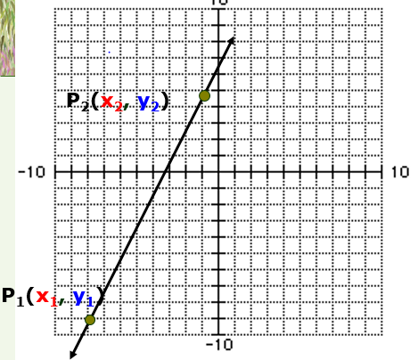  Slope is a ratio and can be expressed as:  ________________________________ ________________________________ _______________________________  Slope Formula:  Note: The order of ____________________________________________ is important.  - Calculate the slope between (-3, 6) and (5, 2).  Check by finding the slope from a graph.  - Find the slope between (5, 4) and (5, 2).  Check by finding the slope from a graph.  - Find the slope between (5, 4) and (-3, 4).  Check by finding the slope from a graph.
Vocabulary:

Example 4: Find the Slope

Example 4 (Continued): Find the Slope

Vocabulary: | Types of Slopes:  - 2.  3. 4.
Homework:

