College Algebra Fundamentals

Section P-4 (Part 3): Lines in the Plane and Slope
Date: ________________________________
Objectives:
- Students will be able to write linear equations using Point-Slope form and Standard form.
Main Idea | Notes
Vocabulary:  Example 1: Point-Slope Form  Example 1 (Continued): Point-Slope Form | When using Point-Slope form, the graph must be a ______________________________  ______________________________________. Use this when given a  ________________________ and a ________________________.  Point-Slope Form:  - Find the equation of the line through the point (1,-2) with a slope of 3.  Point-Slope Form:  Rewrite the equation in Slope-Intercept form:  - Find the equation for the line passing through the points (3,-2) and (6,10)  Point-Slope Form:  Rewrite the equation in Slope-Intercept form:
Example 2: Lines Used for Estimation  Vocabulary:  Vocabulary: | The cash flow per share for Verizon was $2.38 in 1998 and $2.80 in 1999.  - Using only this information, write a linear equation that gives the cash flow per share in terms of the year.  - Predict the cash flows in 2000, 2001, and 2002.  Names for Prediction Methods:  The prediction method in the last example is called ______________________________________  ______________________________________________. These points lie ______________________________  the given points.  Draw a sketch of this below:  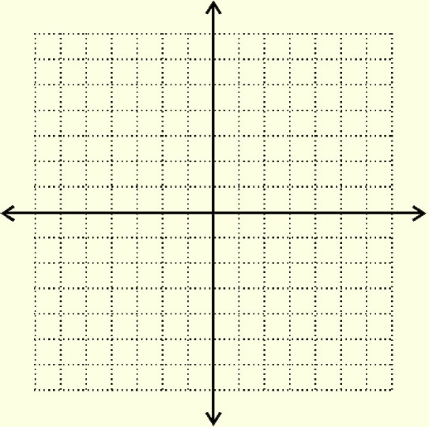  When the estimate point lies _______________________________________________________________  _________________________________________________, the method is called linear interpolation.  Draw a sketch of this below:  Summary of the Equations of Lines:  - _________________________________________________________________________________  - _________________________________________________________________________________  - _________________________________________________________________________________  - _________________________________________________________________________________  - _________________________________________________________________________________
Homework:

