Trigonometry

Section P-5 (Part 1): Functions
Date: ________________________________
Objectives:
- Students will be able to understand relationships in the real world.
- Students will be able to identify the domain and range of a relation and a function.
- Students will be able to determine if a relation is a function.

Main Idea | Notes
“Do Now”  (3 minutes) | Many things in the world are related. Think about things in the world that relate quantities by some rule.  Write down the rule with the quantities that are being related below:
Vocabulary:  Vocabulary: | Relation:  Domain:  Range:  Mapping Diagram:
Example 1: Find the Domain and Range | Write the domain and range of each relation:  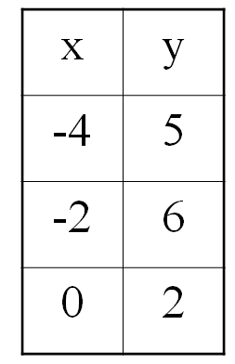  Domain: _________________________ Range: ____________________________  - {(-4, 3), (-1, -2), (0, -4), (2, 3), (3, -3)}  Domain: _________________________ Range: ____________________________  Function:  A function f is a relation in which _________________________________________________________  ________________________________________________________________________________________________  There is one and only one __________________________ with each ___________________________.
Vocabulary:
Example 2: Domain and Range of a Function  Vocabulary: | Write the domain and range of the function.  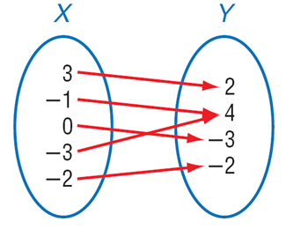 Domain: ___________________ Range: ________________________  Types of Functions:  One-to-One Function:  Not One-to-One Function:  Not a Function:
Example 3: Relations and Functions | Decide whether the following relations are functions (write yes/no):  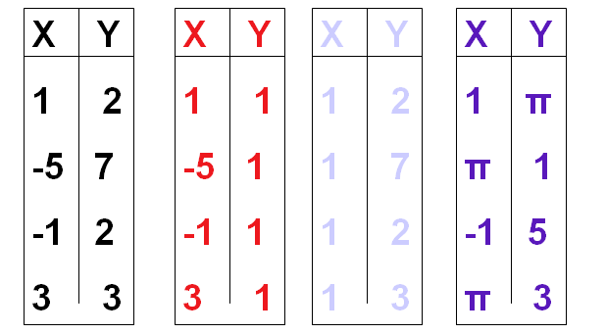  ____________ ____________ ____________ ____________
Example 3: Relations and Functions (Continued) | Decide whether the following relation is a function (write yes/no):  - {(1,3), (2,3), (3,3)}  _____________________
“Exit Ticket”: | Decide if the Relation is a Function. Explain why or why not.  - The relation is the year and the cost of a first class stamp.  - The relation is the weight of an animal and the beats per minute of its heart.  - The relation is the time of the day and the intensity of the sun light.  - The relation is a number and its square.  - The relation is the time since you left your house for work and your distance from home.
Homework:

