Trigonometry

Section P-5 (Part 3): Functions
Date: ________________________________
Objectives:
- Students will be able to understand what a limited domain is and how a function itself can limit that domain.
- Students will be able to find the domain of any function algebraically.
Main Idea | Notes
Vocabulary: | It is not always true that the domain and range can be ___________________________________  _______________________________________________________. Sometimes mathematicians want  to study a function over a _________________________________________.  Example: They might think of the function y = x² - 4, where x is only between -3 and 3 inclusive. How would you write this domain in interval notation?  Sometimes the ________________________________________ limits the domain and range.
Example 1:  Limited Domains  Vocabulary:  Example 2:  Limited Domains  Example 3: Find the Domain of the Function  Example 3 (Continued): Find the Domain of the Function  Homework: | What would be the domain of the function $\frac{1}{x-3}$? Explain why.  What are the most common rules of algebra that limit the domain?  Rule 1: ________________________________________________________________________________________  Rule 2: _________________________________________________________________________________________  What would be the domain of the function $\sqrt{x}$? Explain why.  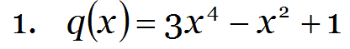  This is a __________________________________________ function. What is the domain? Explain why.  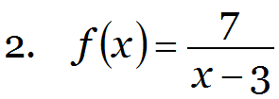  This is a __________________________________________ function. What is the domain? Explain why.  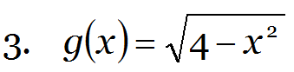  This is a __________________________________________ function. What is the domain? Explain why.

