Trigonometry

Section P-5 (Part 4): Functions
Date: ________________________________
Objectives:
- Students will be able to write and analyze functions that represent real world situations.
- Students will be able to evaluate a difference quotient.
Main Idea | Notes
Example 1: Writing a Distance Function  Example 2: The Dimensions of a Container  Example 3: Evaluating a Difference Quotient | Suppose a car travels at 70 miles per hour. Let y be the distance the car travels in x hours.  Write the formula that would represent your total distance in terms of time.  Does this formula represent a function? Explain  Rewrite the equation in function notation.  What is f(3)? Interpret this output in the context of this problem.  Let’s pretend that you work in the marketing department of a soft drink company. You are experimenting with a new soft-drink can that is slightly narrower and taller than a standard can.  For your experimental can, the ratio of the height to the radius is 4. Label the can below.  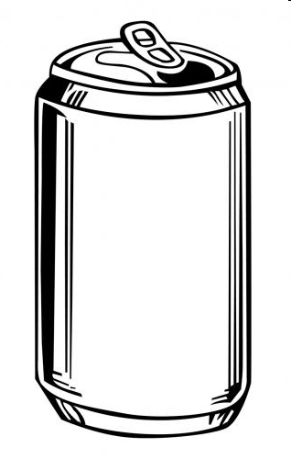  - Express the volume of the can as a function of the radius r  - Express the volume of the can as a function of the height h  For f(x) = x² - 4x + 7, find $\frac{f\left(x+h\right)-f(x)}{h}$.
Homework:

