Trigonometry

Section P-6 (Part 1): Analyzing Graphs of Functions
Date: ________________________________
Objectives:
- Students will be able to analyze the graph of a function (zeros, domain, range, and function values).
Main Idea | Notes
Vocabulary:  Example 1: Finding the Zeros of a Function | The __________________________________________________________________ is the collection of ordered pairs (x, f(x)) such that x is in the domain of the function.  Label all parts of the graph below:  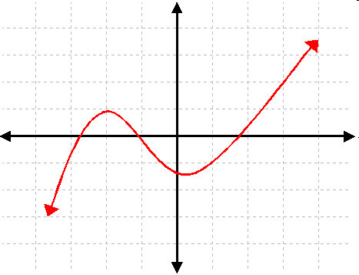  Remember, if a graph of a function, f, crosses the x-axis, then the function has an  __________________________________________________________.  The x-intercept(s) of a function are called the ___________________ or ______________________ of the function.  Find the zeros of the function. Remember, you need to find all values that satisfy the equation f(x) = 0.  - 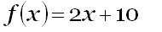  - 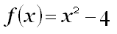
Vocabulary:  Example 2: Determining the Domain and Range from the Graph of a Relation  Example 2 (Continued): Determining the Domain and Range from the Graph of a Relation  Example 3: Finding Function Values  Vocabulary:  Example 4: Find the Domain and Range  Homework: | Think of the _____________________________________as the set of x values that work.  Think of the_____________________________________ as the set of y values that work.  Remember: To find the _________________________________ of a function, find all values  that make the function _____________________________________________ and throw them out  of the ___________________________________________________________________.  Find the domain and range of each graph. Write your answer in interval notation.  x  y  x  y  x  y  x  y  x  y  x  y  Given the graph, find each function value by inspecting the graph.  x  y  f(x)  - f(0) = ___________  - f(4) = ___________  - f(-5) = ___________  - f(-6) = ___________  A _______________________________________ dot indicates that the point belongs to the graph.  An ____________________________ dot indicates that the point does not belong to the graph.  An_______________________________________ indicates that the graph extends indefinitely in the direction in which the arrow points.  Use the graph of the function f to answer the following questions.  -5  -4  -3  -2  -1  1  2  3  4  5  5  4  3  2  1  -1  -2  -3  -4  -5  - What is the domain of f (x)?  - What is the range of f (x)?

