Trigonometry

Section P-6 (Part 4): Analyzing Graphs of Functions
Date: ________________________________
Objectives:
- Students will be able to relate different types of symmetry to functions by testing whether it is even or odd.
- Students will be able to graph the basic functions.
Main Idea | Notes
Vocabulary:  Example 1: Even Functions  Example 2: Complete the Symmetry  Example 3: Odd Functions  Vocabulary:  Vocabulary: | A function is _______________________ if the graph is symmetric with respect to the y-axis.  A function is _______________________ if the graph is symmetric with respect to the origin.  Tests for Even and Odd Functions:  The function f is an even function if ________________________________________________________  _________________________________________________________________________________________________.  The function f is an odd function if ________________________________________________________  _________________________________________________________________________________________________.  Show that f(x) = x^{2/5} is even.  Complete the graph shown assuming that the function is even:  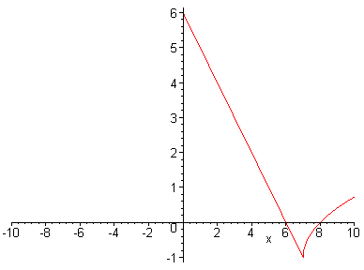  Show that y = x³+x is odd.  Write down each of the 6 common functions and graph them:  - _____________________________________________________  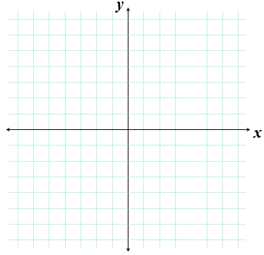  - _____________________________________________________  - _____________________________________________________  - _____________________________________________________  - _____________________________________________________  - _____________________________________________________
Homework:

